**Wireframe documentation**

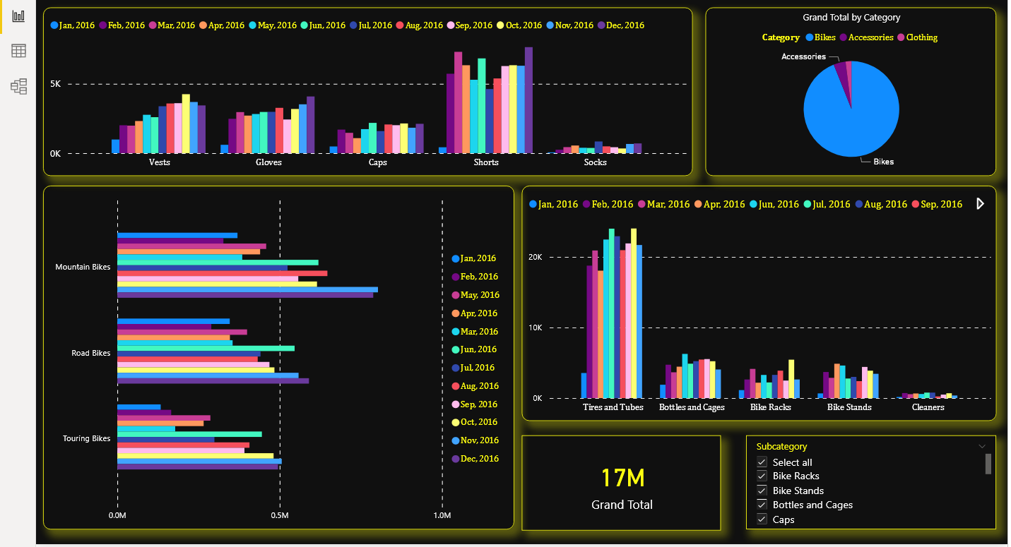

**Cloths sales in Bike Showroom:-**

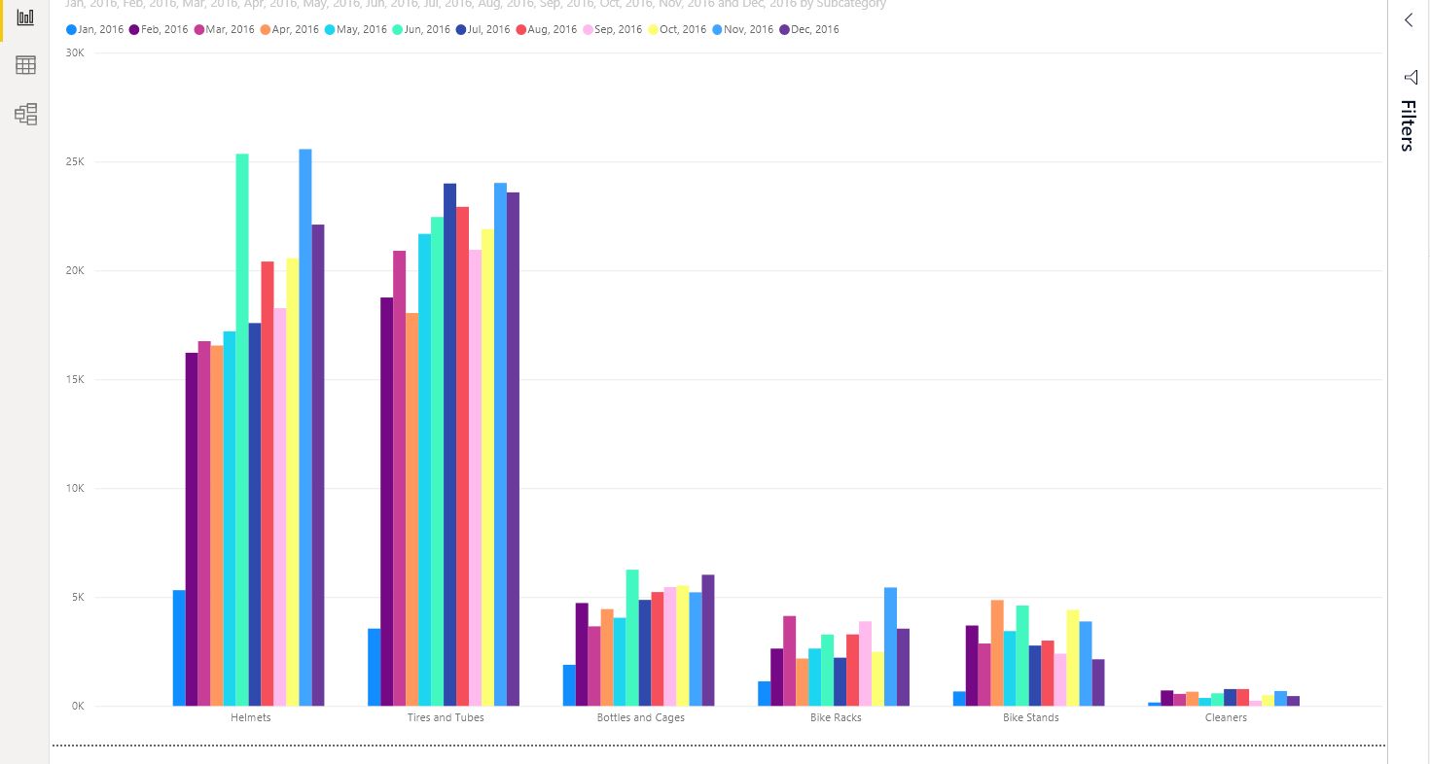In this analysis see that when one product sales are increasing the respective product sales are increasing. For example when jersey sales are increased then all product sale increases automatically.

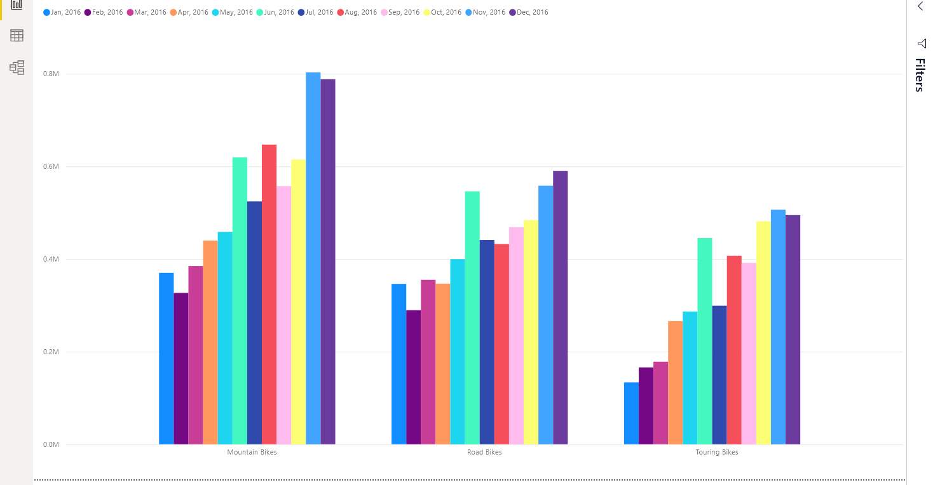**Bike sale:-**

